EXPERIMENT 5
Aim
To analyze the Customer Churn dataset using Python by creating a calculated field and basic visualizations such as bar charts, line charts, and pie charts.
Procedure
1. Import Pandas, Matplotlib, and Seaborn libraries.
2. Load the Customer Churn CSV dataset.
3. Inspect the dataset.
4. Create a calculated column named Customer Status.
5. Create a bar chart for customer churn by contract type.
6. Create a line chart for average monthly charges by tenure.
7. Create a pie chart for active and churned customers.
8. Display the visualizations.
Python Code
import pandas as pd
import matplotlib.pyplot as plt
import seaborn as sns

# Load dataset
df = pd.read_csv("WA_Fn-UseC_-Telco-Customer-Churn.csv")

# 1. Create calculated field
df["Customer Status"] = df["Churn"].apply(
lambda x: "Churned" if x == "Yes" else "Active"
)

print(df[["Churn", "Customer Status"]].head())

# 2. Bar Chart - Churn by Contract
sns.countplot(
x="Contract",
hue="Customer Status",
data=df
)

plt.title("Customer Churn by Contract Type")
plt.xlabel("Contract Type")
plt.ylabel("Number of Customers")
plt.xticks(rotation=20)
plt.show()

# 3. Line Chart - Monthly Charges by Tenure
monthly = df.groupby("tenure")["MonthlyCharges"].mean()

plt.plot(monthly.index, monthly.values, marker="o")

plt.title("Average Monthly Charges by Tenure")
plt.xlabel("Tenure (Months)")
plt.ylabel("Average Monthly Charges")
plt.grid()
plt.show()

# 4. Pie Chart - Customer Status
status = df["Customer Status"].value_counts()

plt.pie(
status,
labels=status.index,
autopct="%1.1f%%"
)

plt.title("Customer Churn Distribution")
plt.show()
Code Output
Churn Customer Status
0 No Active
1 No Active
2 Yes Churned
3 No Active
4 Yes Churned
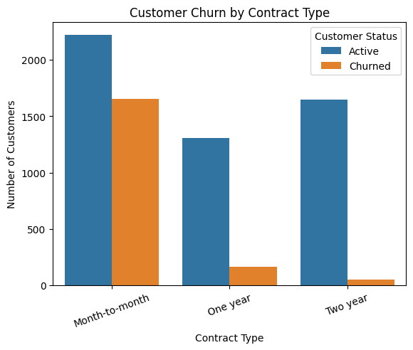
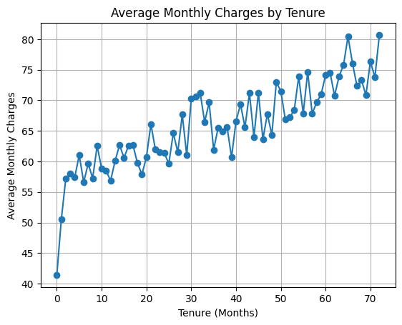
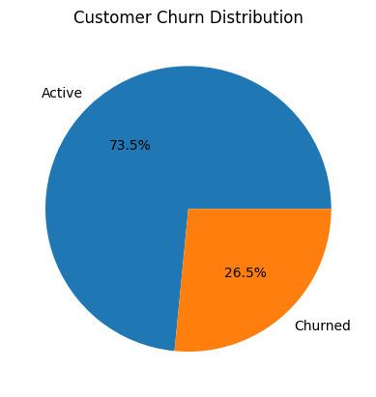
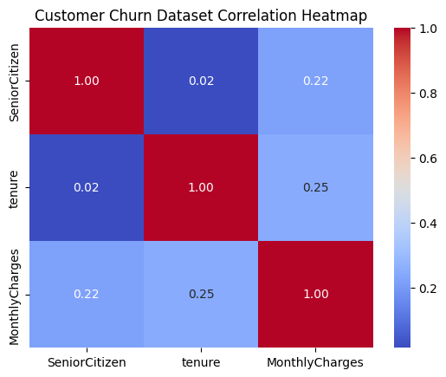

Result
The Customer Churn dataset was successfully analyzed using Python. A calculated field was created and the data was visualized using bar, line, and pie charts. The visualizations provide a clear understanding of customer churn patterns.

